Use-Case Realization Report (Analysis)
Export Cylinder Queues Information

Issue 1.0
Revision History
Date | Issue | Description | Author
29/Apr/2011 | 1.0 | Initial Document | Koh Ming Jin

Table of Contents
1. Brief Description 4
2. Flow of Events 4
2.1 Standard Flow 4
2.2 Exception 4
3. Interaction Diagrams 4
3.1 Collaboration Diagram for Export Cylinder Queues Information 4
4. Participating Objects 5
4.1 Export Cylinder Queues Information Page 5
4.2 Workflow Controller 5
4.3 Step Controller 5
4.4 Cylinder Controller 5
4.5 Step 5
4.6 Cylinder 5
4.7 Workflow 5
5. Class Diagrams 5
5.1 Domain Class Diagram: Export Cylinder Queues Information 5
6. Derived Requirements 6

Use-Case Realization Report
Export Cylinder Queues Information

Brief Description
This use case enables an operation manager to export the cylinder queues information.

Flow of Events
The standard flow of events for this use case and any exceptions are described in the following subsections. See section 3.1 for an overview of the participating Actors and Domain Objects.

Standard Flow
The flow of events is described as follows:

- The use case starts when the authenticated Operation Manager views a list of workflows.
- The Operation Manager selects the Export Cylinder Queues Information option for a particular workflow.
- The Export Cylinder Queues Information Page is displayed for the Operation Manager to verify the detailed information.
- Once the Operation Manager has verified the information and choose the destination export location, he/she will click the export button.
- The Cylinder queues information will be exported and saved into the hard drive.
- The use case terminates.

Exception
- File destination location not found. If the destination location is not found, a warning message will display to alert the user that the export process has failed.
- Read/Write access rights for the destination location. If the user account does not have the read/write access rights, a warning message will display to alert the user that the export process has failed.

Interaction Diagrams

Collaboration Diagram for Export Cylinder Queues Information
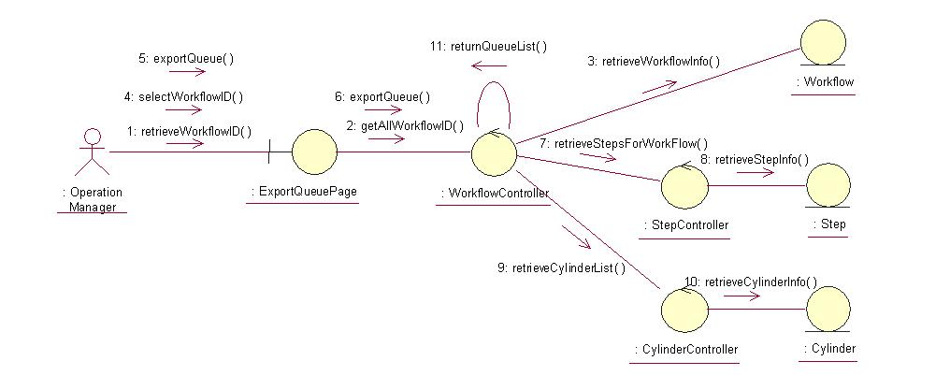

Participating Objects

Export Cylinder Queues Information Page
This object renders the contents to allow authorized actors to perform the export Cylinder queues information request. The Director, Department Manager and Operation Manager actors use this object.

Workflow Controller
This object acts as the middleman between “Export Cylinder Queues information” Page and the Step Controller object. It will translate interactions with the view into actions to be performed by the Step Controller, Cylinder Controller, Step and Cylinder objects.

Step Controller
This object acts as the middleman between Workflow Controller and Step object. It will translate requests by Workflow Controller into actions to be performed by the Step object.

Cylinder Controller
This object acts as the middleman between Step Controller and the Cylinder object. It will translate requests by Step Controller into actions to be performed by the Cylinder object.

Step
This object stores the details concerning the step information of the COMS.

Cylinder
This object stores the details concerning the cylinder information of the COMS.

Workflow
This object stores the details concerning the workflow information of the COMS.

Class Diagrams

Domain Class Diagram: Export Cylinder Queues Information
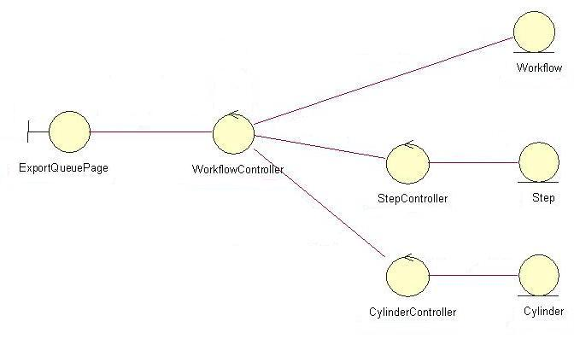

Derived Requirements
The Operation Manager PC keyboard and mouse will be used to retrieve queue details (if any) and view all the system responses.

